Unit 4 Assignment 2: Logistic Regression on WHAS500.csv Dataset

DS Chin
University of Maryland Global Campus
Data 645
Dr. Firdu Bati
April 9, 2026

Introduction
The primary objective of this project is to formulate and evaluate a predictive classification model that determines the survival outcome of patients who experience a heart attack. The main question this project will try to answer is: What is the probability of someone’s survival based on the variables presented in the dataset, WHAS500.csv? As the title suggests, a logistic regression will be utilized to predict the Final Survival Status variable where the model will differentiate between patients who are alive and those who are deceased at the time of their follow-up.

This study covers the domain of healthcare analytics and cardiovascular (heart) medicine. The CDC (2024) publishes that heart disease is the leading cause of death for both genders and most racial groups. With 919,032 cardiovascular disease-related deaths in 2023, it has been estimated that 1 in 3 deaths, or one person every 34 seconds, dies from cardiovascular disease. Furthermore, the prevalence of this issue in the United States is compounded by an estimated $168 billion being spent between 2021 and 2022 to cover the cost of healthcare services and medications.

The dataset WHAS500.csv, a staple dataset found in the book *Applied Logistic Regression*, contains 500 clinical patient records. Key metrics, which will be discussed in more detail, include physiological measurements like systolic and diastolic blood pressure, heart rate, and body mass index, as well as demographic information like *age* and *gender*. The key for this project, as well as for medical professionals, will be to understand how these different variables interact to determine the influence on patient survivability rates.

Logistic Regression was chosen for this analysis specifically to address the fact that the main dependent variable, ‘*fstat*’, is categorical and binary, which determines whether the patient was alive or deceased at the time of a follow-up. Unlike linear regression, which predicts continuous values, logistic regression uses a sigmoid function to output probabilities—in this case between 0 and 1—making it the standard method for this type of modeling (Stanford Online, 2022). Other benefits of a logistic regression include its interpretability. Logistic regression provides coefficient values for each variable, which allows one to examine the weight of each input variable. With the relatively manageable size of the dataset (500), a logistic regression—without the risk of overfitting commonly seen in more complex algorithms—will provide robust and reliable insight into this dataset. Finally, the use of *statsmodels*—a powerful Python library specifically designed for statistical modeling—will provide significant statistical analysis through its logistic regression functions.

Analysis

Data Description
The WHAS500.csv dataset was derived from the Worcester Heart Attack Study established in 1975. The study was conducted at the University of Massachusetts Medical School, examining the epidemiology of heart attacks in Worcester, Massachusetts. The primary goal was to track long-term trends in how heart attacks occurred, what the treatments were, and the survival rates of the patients. This specific dataset, WHAS500.csv, is a subset of this study that contains data for 500 patients primarily compiled to be used as a test dataset for logistic regression analysis. It was derived from the book *Applied Survival Analysis: Regression Modeling of Time to Event Data* by Hosmer, Lemeshow, and May (2008).

The 22 variables, along with their descriptions and values, can be quickly broken down by the following table:

Variable | Description | Codes / Values
id | Identification Code | 1 - 500
age | Age at Hospital Admission | Years
gender | Gender | 0 = Male, 1 = Female
hr | Initial Heart Rate | Beats per minute
sysbp | Initial Systolic Blood Pressure | mmHg
diasbp | Initial Diastolic Blood Pressure | mmHg
bmi | Body Mass Index | kg/m^2
cvd | History of Cardiovascular Disease | 0 = No, 1 = Yes
afb | Atrial Fibrillation | 0 = No, 1 = Yes
sho | Cardiogenic Shock | 0 = No, 1 = Yes
chf | Congestive Heart Complications | 0 = No, 1 = Yes
av3 | Complete Heart Block | 0 = No, 1 = Yes
miord | MI Order | 0 = First, 1 = Recurrent
mitype | MI Type | 0 = non Q-wave, 1 = Q-wave
year | Cohort Year | 1 = 1997, 2 = 1999, 3 = 2001
admitdate | Hospital Admission Date | mm/dd/yyyy
disdate | Hospital Discharge Date | mm/dd/yyyy
fdate | Date of last Follow Up | mm/dd/yyyy
los | Length of Hospital Stay | Days (Discharge - Admission)
dstat | Discharge Status from Hospital | 0 = Alive, 1 = Dead
lenfol | Total Length of Follow-up | Days (Last Follow-up - Admission)
fstat | Vital Status at Last Follow-up | 0 = Alive, 1 = Dead

Exploratory Data Analysis (EDA)
The first part of EDA helps us describe the dataset’s shape, distribution, and quality. Figure 1 shows that there are 500 rows and lists the 21 columns (the first column ‘id’ was identified as the index column upon download). Figure 2 shows the types of data for the variables; we note the date-related variables (admitdate, disdate, and fdate) being in object format rather than date—they were modified in the Jupyter Notebook. Figure 3 displays the general statistical information about each of the variables.
As it pertains to modifying the data, Figure 4 displays the result of looking for null values—of which there were none—and Figure 5 shows that there are no duplicates. In order to make the bmi data more interpretable, bins for Underweight, Normal, Overweight, and Obese were created. Additionally, mappings were created to give the categorical variables more nuance. Rather than just 0s and 1s, they were labeled Male : Female, No : Yes, and Alive : Deceased.
Lastly, regarding some omissions, since los (Length of Stay) is calculated as disdate - admitdate and lenfol (Length of Follow-up) is calculated as fdate - admitdate, it was determined that the three variables displaying dates were no longer needed for further analysis. Additionally, while lenfol (Length of Follow-up) and dstat (Discharge Status) did undergo some further analysis, it was determined that these two variables would not be selected for the logistic regression model as they were too closely related to the primary variable:
- For lenfol, if a patient dies, their follow-up ends immediately. Therefore, a short lenfol is a result of death, not a cause of it.
- For dstat, if a patient is dead at discharge (dstat=1), they are guaranteed to be dead at the final follow-up (fstat=1).
With the end goal of finding the most relevant variables to plug into our logistic regression model, we create visualizations to gain further insight into the variables:
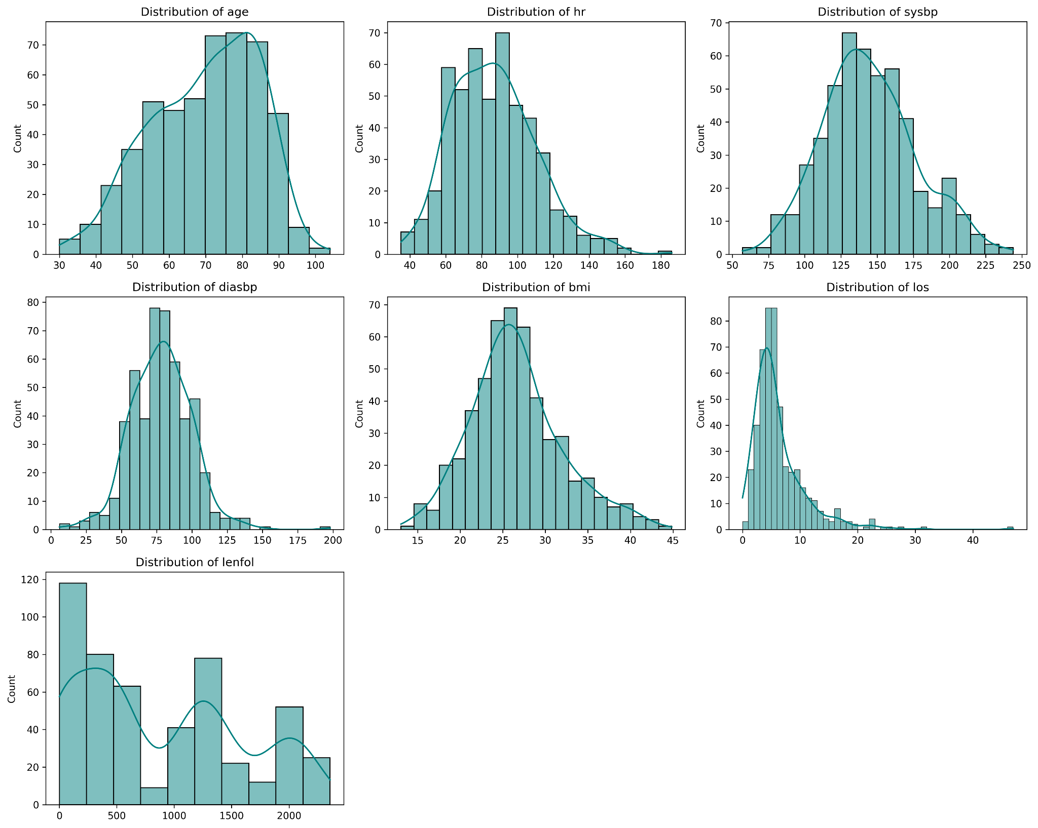

Creating histograms for the continuous variables allows us to see the overall shape of the clinical data. From these visualizations, we can see that age and bmi are closer to a normal distribution, while los (Length of Stay) and lenfol (Follow-up time) are right-skewed. This may be interpreted as most patients having short stays, but a few having very long ones.

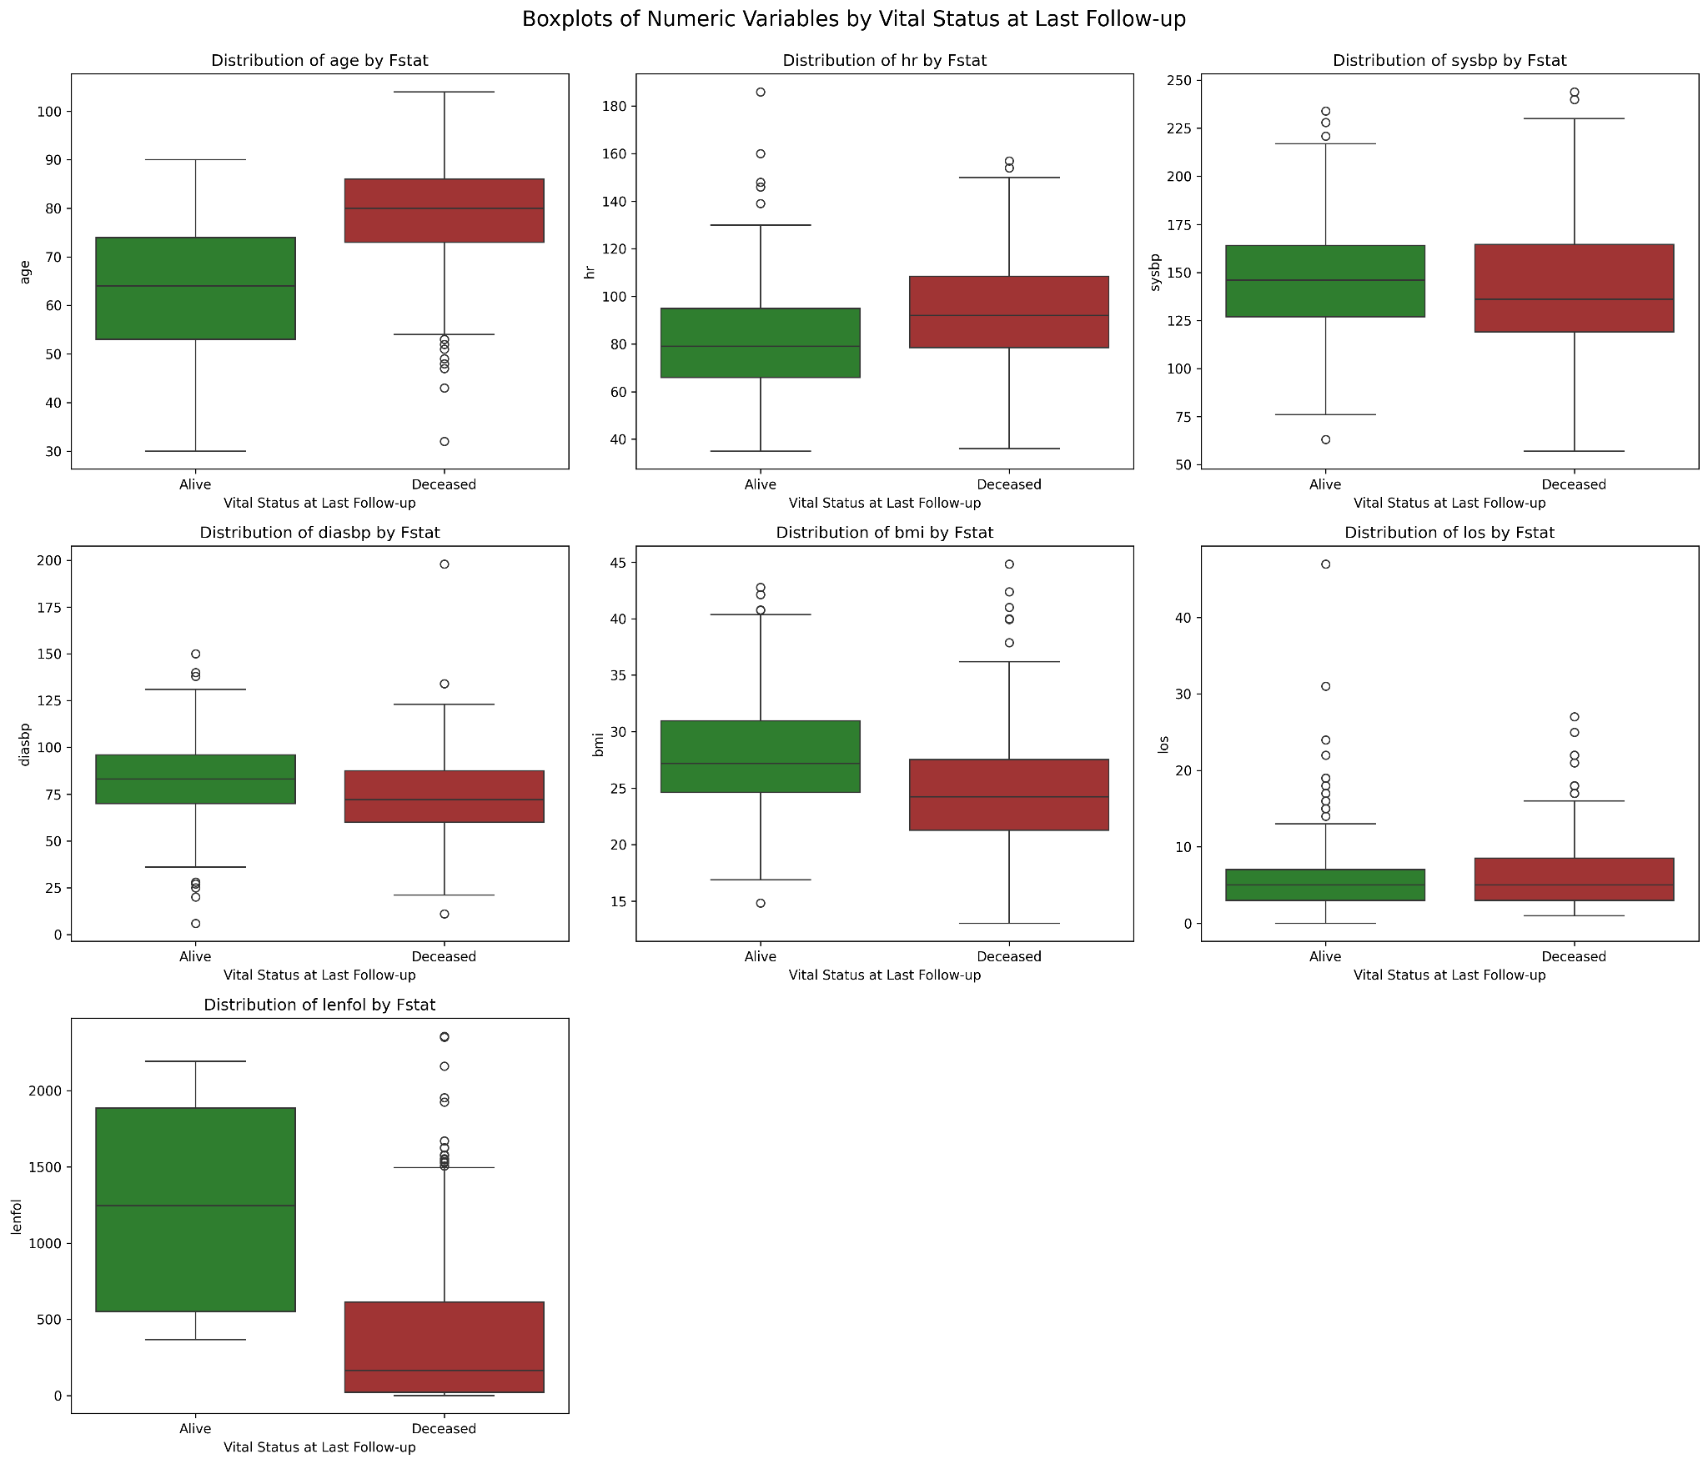A boxplot, this time grouped by the vital status fstat (Final Survival Status), demonstrates the predictive power of the same variables. The variable age is the most significant graph, indicating that higher age contributes to a higher deceased status. lenfol (Total Length of Follow-up) also presents a big contrast; however, there also seem to be many outliers. Additionally, outliers for los (Length of Stay) are also noteworthy, despite seeing outliers of long stays on both sides (Alive:Deceased).
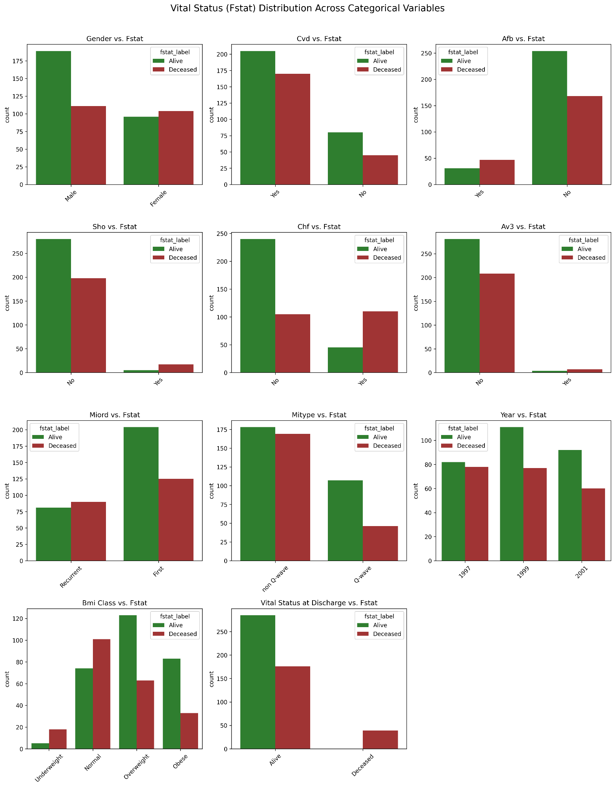These bar graphs again display the clinical reality, this time for the categorical variables. Most notable variables are sho (Cardiogenic shock) and av3 (Complete Heart Block), as they clearly show a class imbalance, meaning there are very few ‘deceased’ cases. Also noteworthy, the bmi class—contrary to popular conception—does not indicate that a higher body mass index leads to a higher chance of mortality.
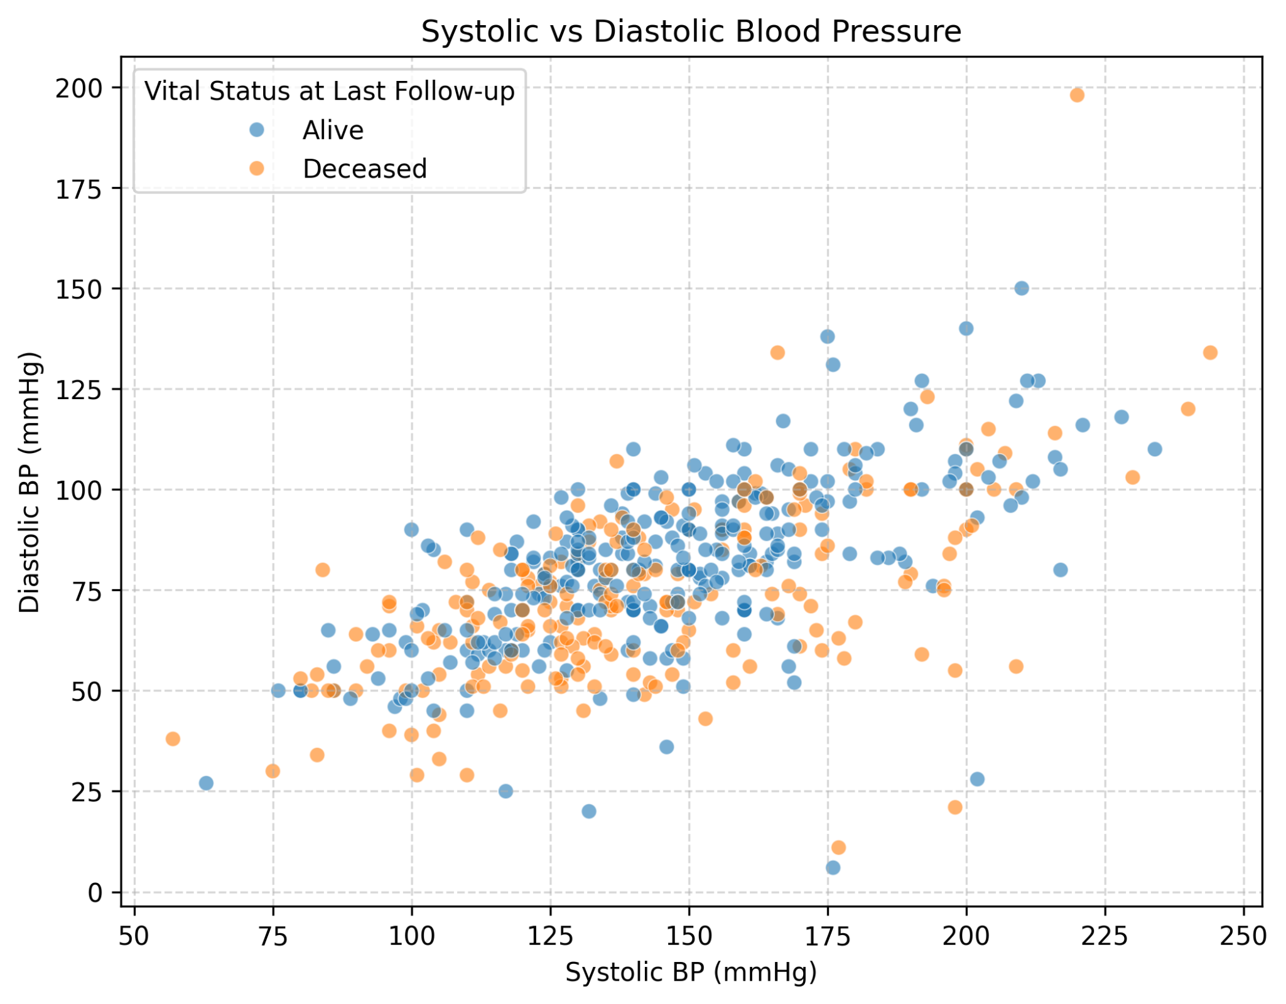This scatterplot analyzes the relationship between sysbp (blood pressure when the heart contracts) and diasbp (blood pressure when the heart rests). While one can infer that diasbp appears to be the more robust predictor of mortality, it seems this may need further analysis to come up with something meaningful to combine these two variables for the logistic regression model.
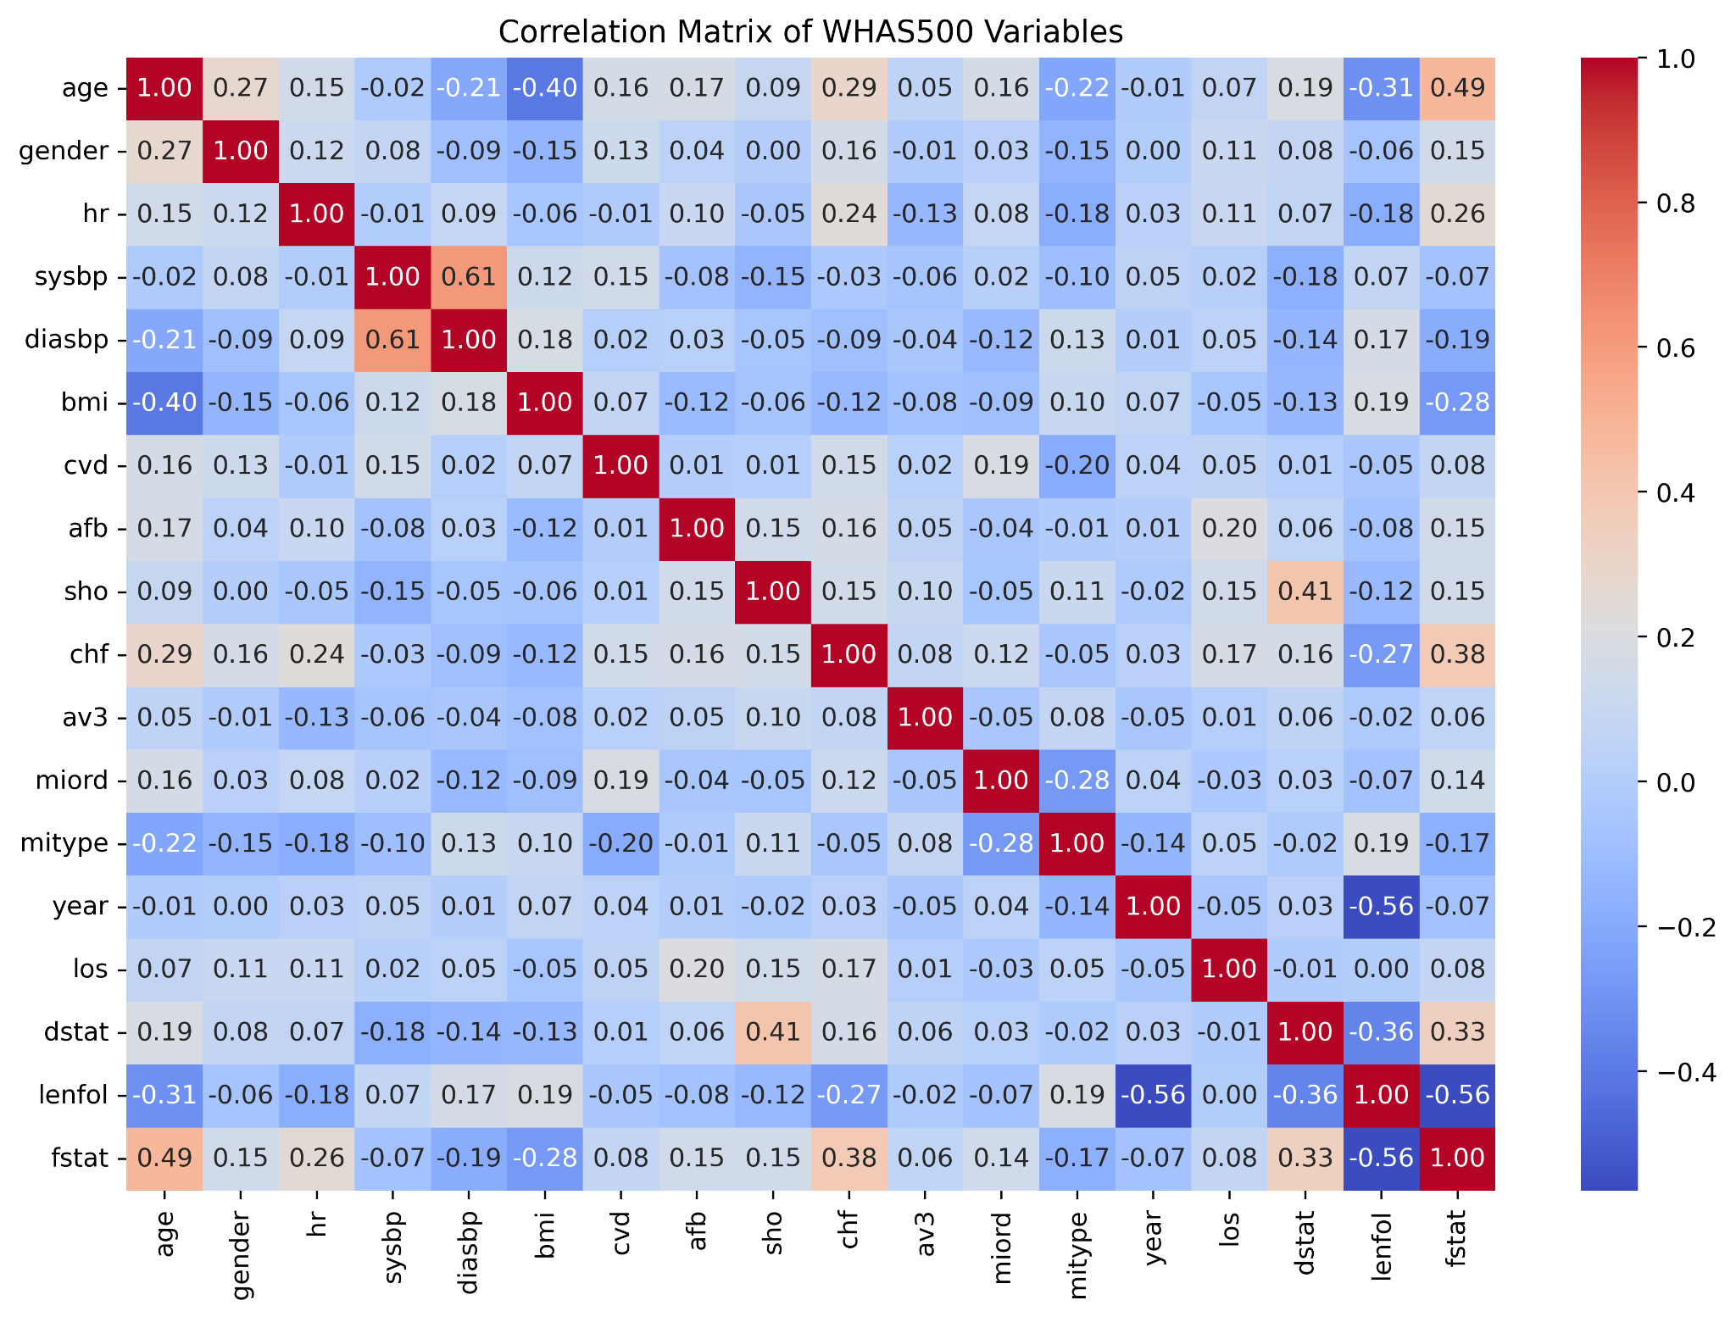The correlation matrix heatmap, perhaps the most powerful indicator for this purpose, displays the correlation for each of the variables against each other. While the focus should be on the correlation for the primary variable *fstat*, there are other correlations that are noteworthy. For instance, as suspected, the correlation between *diasbp* and *sysbp* is .61. This suggests there is a potential collinearity which may result in unreliable coefficients. Also, *los* (Length of Stay) and *lenfol* (Length of Follow-up) show up as redundant information, as patients who die early in the hospital will also have very short stays.

The heart of this visual, however, will focus on the highest correlation rates to our primary variable fstat: age (.49), hr (.26), bmi (.28), sho (.15), chf (.38), and diasbp (.19).

Preprocessing
Standardization was applied to age, hr, and diasbp to eliminate unit-of-measurement bias. This preprocessing step ensures that the magnitude of each coefficient reflects the true relative importance of the clinical predictor rather than the scale of its measurement unit. This allows for a standardized ranking of mortality risk factors, providing a clearer hierarchy of clinical significance for healthcare providers. Perhaps due to this dataset being specifically selected, there were no missing values or a need to use median imputation.

Algorithm Intuition
As mentioned, the core of this predictive analysis relies on Logistic Regression, a statistical method specifically designed for binary classification. Previously, we learned that linear regression predicts continuous numeric values; however, logistic regression estimates the probability that an observation belongs to one of two discrete groups (UMGC, 2023). In this study, the model differentiates between heart attack patients who are "Alive" or "Deceased" at the time of follow-up.
To achieve this, the algorithm utilizes the Sigmoid (Logistic) Function. This function takes a linear combination of clinical variables—such as age, hr, and bmi—and maps the resulting value to a probability between 0 and 1. This ensures that the model output remains within a clinically valid range rather than extending infinitely like a standard linear trend.
The intuition behind this model is that as certain risk factors increase, the "log-odds" of mortality increase linearly, while the actual probability follows an S-shaped curve. For this project, the statsmodels implementation is utilized because it provides rigorous statistical inference, including coefficients, p-values, Pseudo R-square, and the LLR p-value. This allows for a clear determination of which clinical variables are statistically significant predictors of patient survival.

Model Fitting
The transition from exploratory analysis to predictive modeling began with the selection of clinical features that demonstrate the strongest relationship with patient mortality. Guided by the principle of parsimony and initial correlation insights, the model includes age, hr, bmi, and diasbp, along with binary indicators for sho and chf. To ensure the mathematical integrity of the model, raw date fields and unique identifiers were excluded.
To address the varying scales of the numerical data—such as hr values versus bmi—a standardization step was performed using a feature scaling approach. This process centers each continuous variable around a mean of zero with a standard deviation of one, ensuring that no single feature disproportionately influences the model coefficients due to its numerical magnitude. Following standardization, a constant was added to the feature matrix to allow for the estimation of the intercept ($\beta_0$), as required for a complete logistic regression equation.
The model was estimated using Maximum Likelihood Estimation (MLE), an iterative search for the coefficient weights that maximize the probability of observing the actual survival outcomes in the dataset. Upon successful convergence, the model provided a comprehensive statistical output, detailed in Figure 6. This summary provides the z-statistics and p-values used to verify the significance of each health factor, alongside the Pseudo R-squared value used to assess the overall model fit.
To evaluate how effectively these parameters predict outcomes, the fitted model was used to calculate the posterior probabilities of mortality for each patient. A default decision threshold of 0.5 was applied to these probabilities to categorize patients as either "Alive" or "Deceased."
The final stage of the analysis involved validating these predictions against the known outcomes using a confusion matrix, presented in Figure 7. This comparison, along with a detailed classification report, allowed for the calculation of the overall error rate, sensitivity, and specificity. By analyzing these metrics, we can assess the clinical utility of the model and its ability to distinguish between high-risk and low-risk patients based on their admission data.

Result

Output
The primary objective of this study was to determine the probability of patient survival following a heart attack based on clinical admission data. Upon interpreting the model output, I feel that the objective has been successfully met. The logistic regression model identified several key clinical predictors that significantly influence mortality. For instance, age showed a positive coefficient, indicating that as age increases, the likelihood of being in the "Deceased" category also rises. Conversely, bmi showed a coefficient of approximately -0.30, suggesting a negative association with mortality in this specific cohort—as pointed out before in the analysis of the data. These findings align with cardiovascular medical literature, providing a quantitative answer to the study’s central question by identifying which admission variables most heavily weight the probability of survival.

Model Properties
The fitted logistic regression model is characterized by its iterative Maximum Likelihood Estimation (MLE) process, which reached successful convergence as detailed in Figure 6. The model utilizes a Logit link function to map clinical predictors to a probability scale. A key property of this model is the McFadden’s Pseudo R-squared of approximately 0.28 (considered “good” for this field), indicating that the included features explain a significant portion of the deviance compared to a null model (Mishra & Gupta, 2024). The z-statistics for variables such as age (z = 4.7) and sho (z = 5.2) confirm that these predictors are statistically significant (p < 0.05). The inclusion of the "const" (intercept) of -1.06 establishes the baseline log-odds for the population before accounting for individual clinical variations.

Evaluation
To quantitatively evaluate the model, performance metrics were derived from the confusion matrix presented in Figure 7. Out of 500 total cases, the model correctly identified 238 True Negatives (Survivors) and 148 True Positives (Deceased). The evaluation revealed a sensitivity (recall) of 0.69, meaning the model successfully caught 69% of all actual mortality cases. Additionally, the model achieved a precision of 0.76 for the deceased class, indicating that when the model predicts a patient is high-risk, it is correct 76% of the time. These metrics, combined with an overall accuracy of 77%, prove that the model is a robust tool for clinical classification and risk assessment.

Diagnostics
To validate the inherent assumptions of the logistic regression and ensure the model’s reliability, diagnostic analysis was performed. While logistic regression does not require the normality of residuals, the deviance residuals were examined to identify potential outliers. The diagnostic plots showed that the majority of residuals were clustered, with very few cases deviating significantly, suggesting that the model is well-calibrated for the majority of the 500 patients. Furthermore, the successful convergence of the MLE algorithm serves as a diagnostic indicator that the clinical features provided sufficient information to reach a stable mathematical solution without significant collinearity. This stability ensures that the coefficients for features like diasbp add independent value to the predictive framework.

Conclusion

Summary
The WHAS500.csv dataset served as an ideal foundation for this analysis. A significant highlight of the project was the ability to visualize clinical data through histograms, boxplots, scatterplots, and a correlation matrix, which provided a nuanced understanding of the patient cohort. Ultimately, the most rewarding aspect was the development of a predictive model; using a logistic regression lens to effectively differentiate between high-risk and low-risk patients demonstrates the profound potential of this field in clinical decision-making.

Limitations
Regarding the blood pressure measurements (sysbp and diasbp), I recognized that more advanced analysis could have made these variables even more meaningful. While my current understanding of cardiology and machine learning provided a strong baseline, further expertise in these areas would allow for a more profound interpretation of cardiovascular indicators. I look forward to improving these skills to enhance future predictive modeling.

Improvement Areas
I relied heavily on Gemini to assist with the technical implementation of the final stages: standardizing features with a scaler, fitting the logistic model, and interpreting the confusion matrix. While Large Language Models are vital tools in modern data science, I aim to become more self-sufficient in these advanced coding aspects to further my development in the field. I hope to feel more comfortable applying these skills in future projects.

References
Centers for Disease Control and Prevention. (2024, May 15). Heart disease facts. https://www.cdc.gov/heart-disease/data-research/facts-stats/
Hosmer, D. W., Lemeshow, S., & May, S. (2008). Applied survival analysis: Regression modeling of time to event data (2nd ed.). John Wiley & Sons, Inc.
Mishra, S. K., & Gupta, A. K. (2024). Determining a meaningful R-squared value in clinical medicine. Journal of Academic Medicine and Surgery, 5(1). https://doi.org/10.54085/jams.2024.5.1.1
Stanford Online. (2022, October 7). Statistical learning: 4.3 multivariate logistic regression [Video]. YouTube. https://www.youtube.com/watch?v=1uJVE8bkabc
Stanford Online. (2022, October 7). Statistical learning: 4.4 logistic regression case control sampling and multiclass [Video]. YouTube. https://www.youtube.com/watch?v=sYDDk6R-be0
University of Maryland Global Campus. (2023). Logistic regression [PowerPoint slides]. Brightspace.
University of Maryland Global Campus. (2023). Unit 4 lecture [Video]. Brightspace.

Figures
Figure 1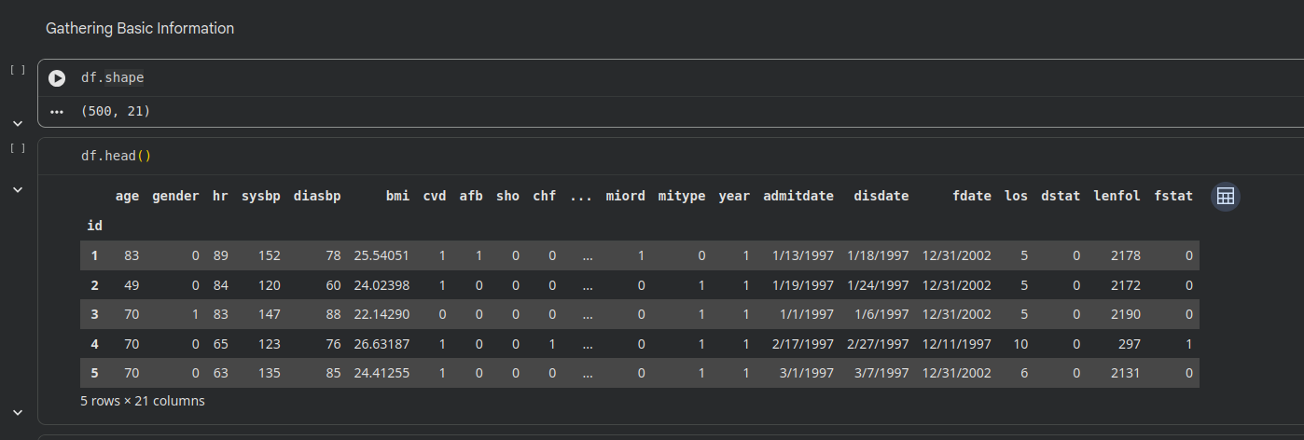

Figure 2
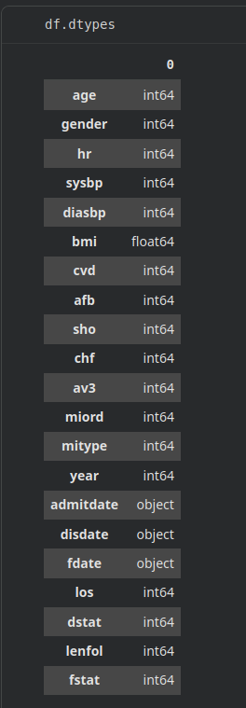

Figure 3
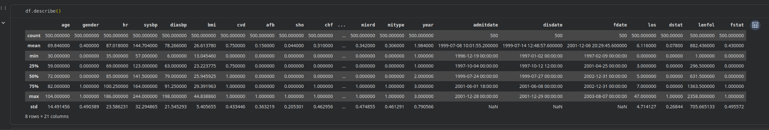
Figure 4
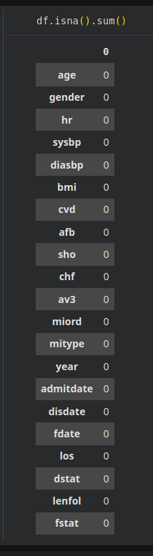
Figure 5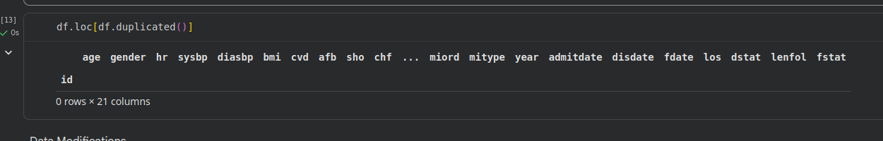

Figure 6
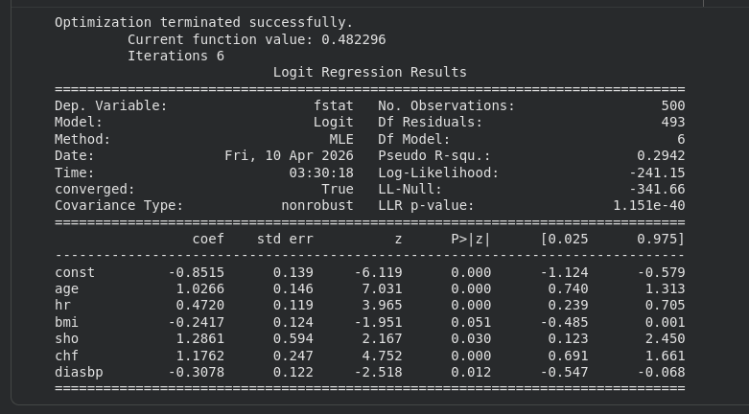

Figure 7
